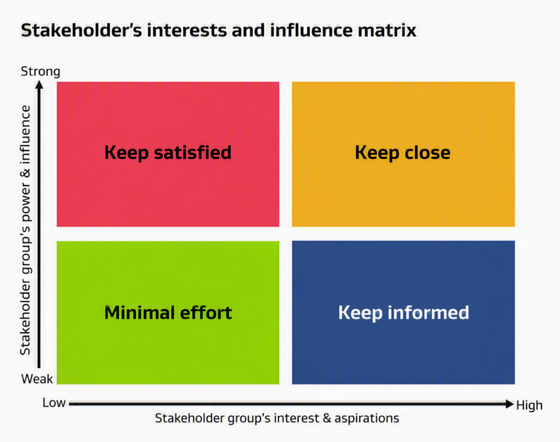
Stakeholder analysis
Stakeholder interest and influence matrix
Use this template to help when initiating a change in your workplace.
To ensure you communicate effectively with all your stakeholders, you should understand where your team members fit in the matrix.
Strong power / influence – Low interest  Keep satisfied | Strong power / influence - High interest  Keep close
Low power / influence – Low interest  Minimal effort | Low power / influence – High interest  Keep informed

