# Walrus Installation Step-by-Step Guide

To start using Walrus client, follow the steps below:

**Step 1:**Download the Walrus client installer from <https://polarexplorer.org.au/Downloads/WalrusClient/setup.exe>

**Step 2:** Run the installer application, setup.exe

[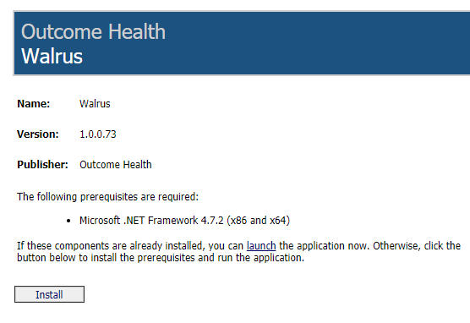](https://kb.polarexplorer.org.au/uploads/images/gallery/2023-12/AWReGGemOD9q9vd7-walrus-installation.png)

**Step 3:**When Walrus starts you will be asked to enter your POLAR username and password.

[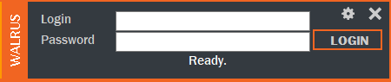](https://kb.polarexplorer.org.au/uploads/images/gallery/2023-12/9Tnd7v8lWq10qncY-installation.png)

POLAR Walrus Video - <https://youtu.be/lLNWNl4j8dc>