Topic | Implementing a Brain Health Check as part of 45-49year HA
CPD | Self-Reporting  Case review/analysis | Hours | EA 4 hours (3 hours webinar & 1-hour self-directed learning)  RP 2 hours
Date | Completed March / April 2023
Aim | To assist General Practitioners to identify and modify any midlife risk factors for dementia.
Learning Outcomes | Evaluate own clinical practice of use of the 45-49 year HA as a way of introducing a brain health check.

Background
General requirements for a 45-49 HA
Please click here to access
Risk factors for Dementia
While obesity and physical inactivity are the most significant risk factors for cognitive decline in high income countries like Australia, globally there are 12 formally recognised modifiable risk factors that should be considered (Lancet Commission 2020), some of which are more important in midlife. Addressing these in the 45-59 yr HA may reduce or delay the onset of cognitive decline.

Why incorporate a brain health check?
Alzheimer’s Dementia is the most common form of dementia. It is the leading cause of death for women, the second leading cause of death overall and the highest cause of morbidity in people aged 65 and over in Australia.

At this stage there are no curative treatments for dementia. However, there are some medications that may provide a modest benefit in some patients and some interventions that can slow down the rate of progression of the disease and improve quality of life for people living with dementia.

So, health prevention is our most effective intervention at this point in time.

You can access the Dementia prevention, intervention, and care: 2020 report of the Lancet Commission here. Take the time to look at the key messages on page 414 and the imagine on the following page.

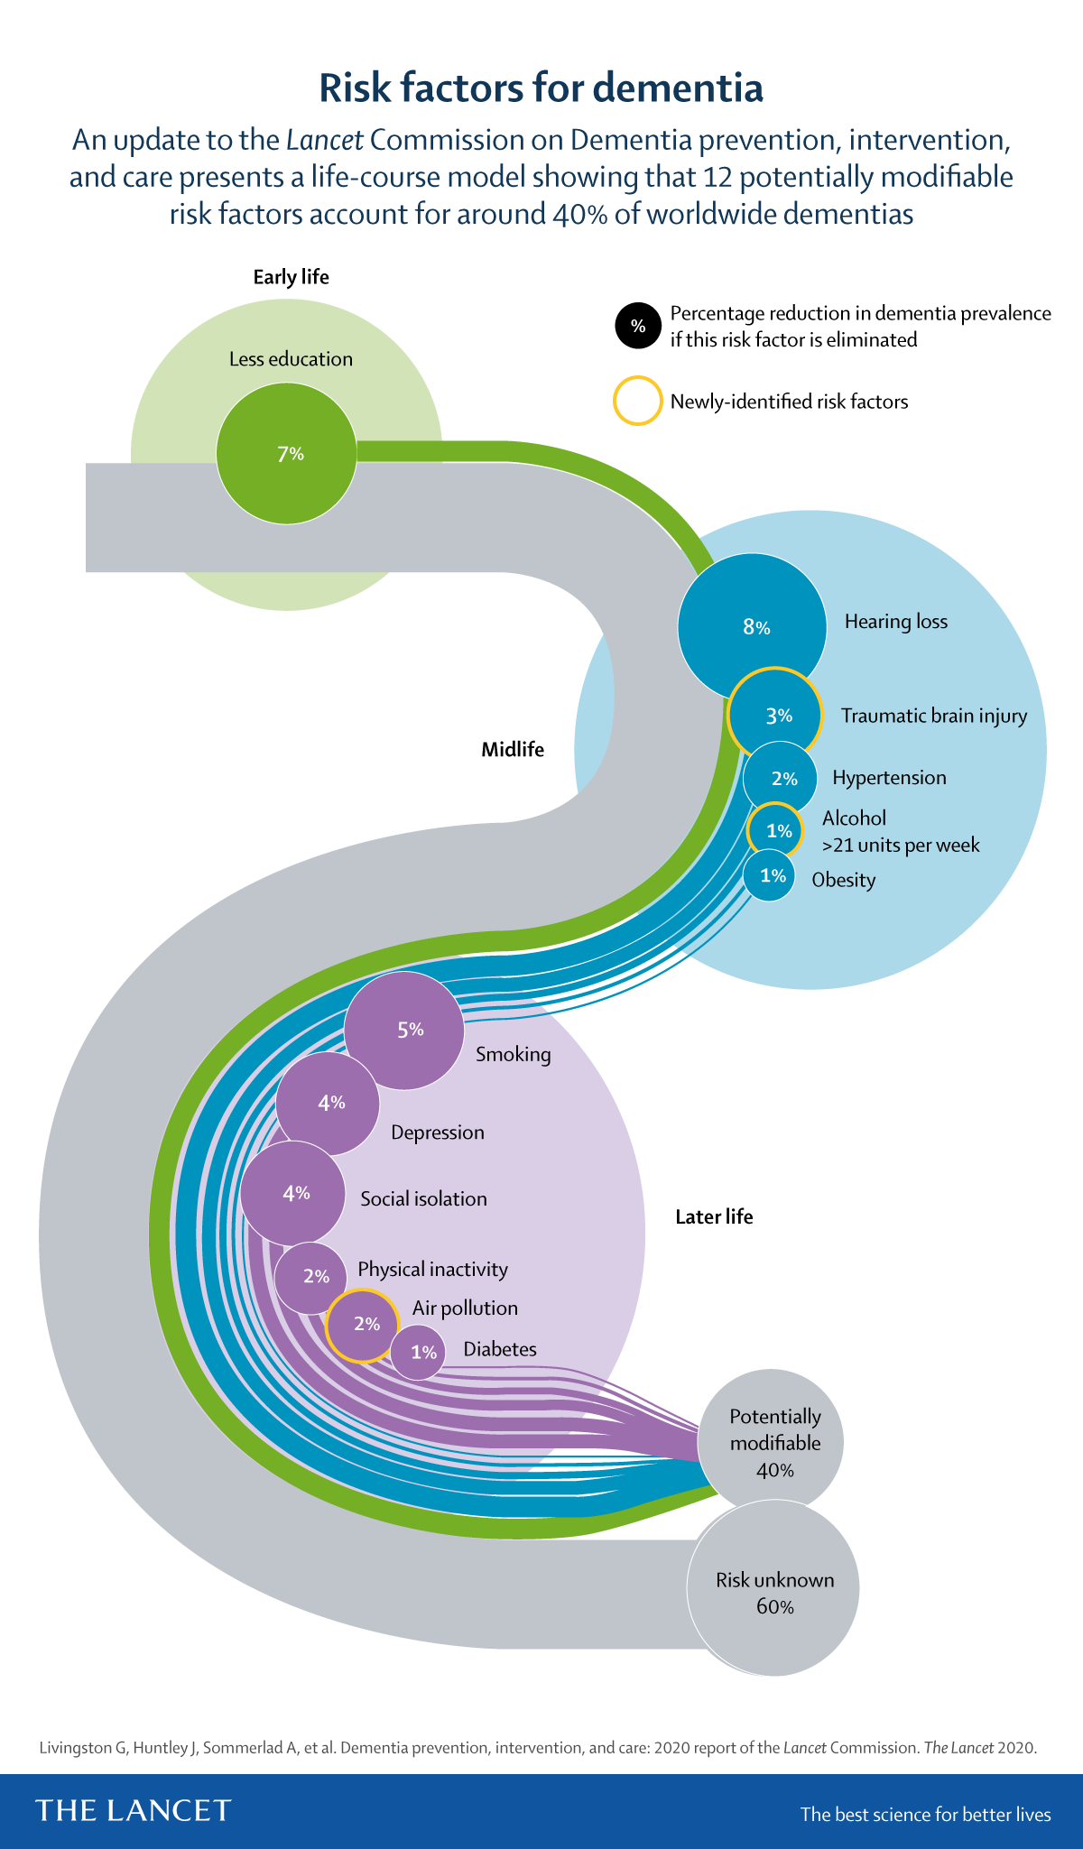

Instructions
- For the next patient who comes in, and is eligible for a 45 -49yr HA
- Identify which of the 12 modifiable risk factors the person has for cognitive decline (or any other risk for chronic disease) making them eligible for a 45-49yr HA
- Offer them the opportunity to complete the CogDrisk Assessment and invite them to make a follow up appointment to discuss the result and plan for any necessary interventions to address their overall risk of cognitive decline
- You may choose to use the GP fact sheets from https://cogdrisk.neura.edu.au/factsheets-for-general-practitioners/ to assist with lifestyle modifications *
- Ask for feedback from the patient to see if they found the process useful

- Having completed the above activities, reflect on how you now might change your practice and approach to the 45 – 49yr HA

