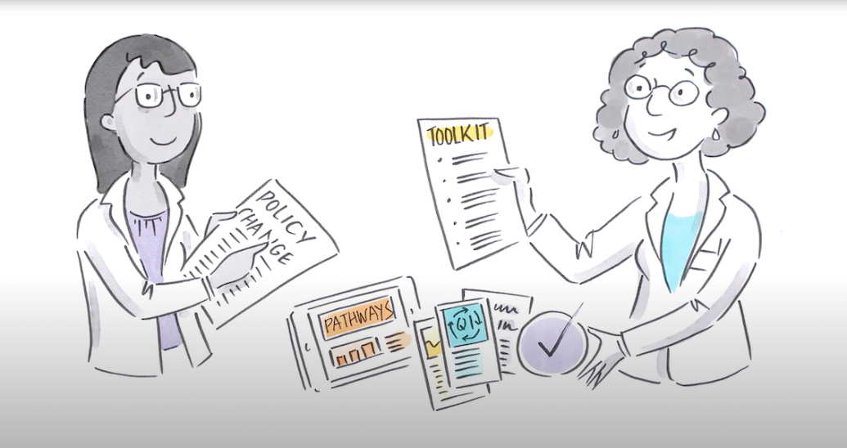
Quality Improvement Record - a template for practices

By documenting Quality Improvement (QI) activities, your practices can build on improvements every year. Keeping a record of each QI also helps to keep your team approaches in one place.
NWMPHN has developed this Quality Improvement Record template for practices to use for any QI activity, small or large. It provides a simple step-by-step approach to help you document your QI journey.
If you prefer to use the guided Quality Improvement Toolkits developed by NWMPHN, visit nwmphn.org.au/for-primary-care/quality-improvement/quality-improvement-toolkits/
TO USE THIS TEMPLATE
- Please save it and add your QI activity title to the document.
- Remove this page of Instructions and make the document your own, but please keep the footer information that acknowledges this template was developed by NWMPHN.
- Complete page two onwards for each QI activity. Copy any tables that need to be repeated.
- If you get stuck please refer to the QI pages and toolkits on the NWMPHN website or contact your NWMPHN relationship manager for more information.

QUALITY IMPROVEMENT {ADD TITLE}
Date
Practice Name
PHN | North Western Melbourne Primary Health Network
Lead contact for this Quality Improvement activity
Name:
Role:
Email:

TABLE OF CONTENTS

1) Model for Improvement 3
2) Before you start 3
3) Part 1: the thinking part 4
4) Part 2: the doing part 5
5) QI activity reflection 6
6) Sharing success and celebration 6

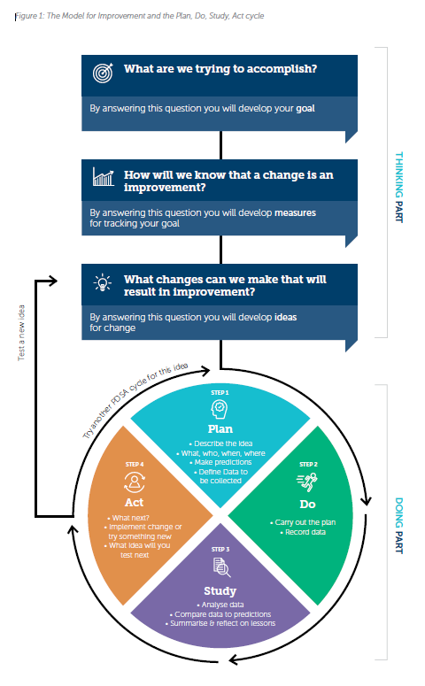
Model for Improvement
This Quality Improvement Record will help you to work your chosen activity.
Each QI activity you do should follow the Model for Improvement (MFI) approach outlined below.
The model is a proven approach for developing, testing and implementing changes in general practice. It helps you to break down your change into manageable pieces. Each is then tested to ensure it results in measurable improvements, and that minimal effort is wasted.
If you are new to quality improvement, it’s a good idea to read the NWMPHN QI guide and tools.
Implementation of the MFI has shown that it works best when you:
- define the problem
- think small and test
- use a whole team approach
- share success and lessons learnt

Before you start

Brainstorm area for improvement
- Get your practice team together and think about some areas where you can make improvements.
- Use data and evidence to identify where you need to make an improvement, or where there is an opportunity for improvement. For example, you could examine:
• Practice feedback from patients, staff or accreditation
• Data (routine practice data, POLAR reports, PIP QI reports)
• Periodic reviews or audits of clinical information
• Local or national health priority areas

Set up the team
Set up a QI team to manage and monitor the activity. Consider:
- Who is in the practice?
- Who will lead the team?
- Who in the practice needs to approve the QI or changes?
- How often will you meet?
- How will you communicate within the team and with other practice staff?

Part 1: The thinking part

As a QI team complete Table 1.
Table 1: The thinking part
 | What are we trying to accomplish?  By answering this question, you will develop your goal
 | How will we know that a change is an improvement?  By answering this question, you will develop measures for tracking your goal
 | What changes can we make that will result in improvement?  By answering this question, you will develop ideas for change

Part 2: The doing part
Considering your ideas captured above, use the plan-do-study-act (PDSA) template below to document and monitor the effect of your changes. Multiple PDSA cycles will likely be required to achieve your improvement goal. Remember, these allow you to test incremental changes. You can download additional PDSA templates here
Table 2. Plan, Do, Study, Act (PDSA)
 | Plan Describe the idea. Who? When? Where? Make predictions and define data to be collected to be able to measure a change
 | Do Carry out the plan. Record data.
 | Study Analyse data, compare data to predictions, summarise and reflect on lessons.
 | Act What next? Will you implement the change or try something new? What idea will you test next? What will you take forward; what is the next step or cycle?

QI activity reflection
Take a moment to document QI team reflections on the activity.
Consider: What worked well, what could have been improved, and what will you do differently next time?

CelebratE and Share Your Success
Celebrating your success doesn’t just feel good—it will help you capitalise on your quality improvement efforts.
By celebrating your wins, you’ll engage your practice team more deeply with your QI project, enhance morale and foster a culture of improvement.
You could share results, such as a successful patient case study or improvements in data measures, at staff meetings, hold a celebratory lunch, share your achievements with patients in the waiting area, or even in local media or online.
SHARE YOUR SUCCESS WITH US
At North Western Melbourne Primary Health Network we love to hear about successful QI initiatives. We can share these great achievements with other practices. Please let us know if you have a QI story that you would like to share with us. Email: primarycare@nwmphn.org.au

