Lately – end of life services and advice

About this pack

*This promotional pack contains suggested copy and resources for organisations to use to promote this valuable new and free service* to your networks. It includes:

|  |
| --- |
|  |
|  |

1. **Background**
2. **About Lately**
3. **Key messages**
4. **Suggested copy**
5. **Social tiles**

If you have any questions or requests, please contact:

* Jesse Osowicki - Manager, Integration, North Western Melbourne PHN [jesse.osowicki@nwmphn.org.au](mailto:jesse.osowicki@nwmphn.org.au)
* Andrew Masterson – Communications and Media Advisor, North Western Melbourne PHN  
  [Andrew.Masterson@nwmphn.org.au](mailto:Andrew.Masterson@nwmphn.org.au)

1. Background

Being cared for and dying at home surrounded by their family and friends is most people’s preference. It seems like a simple and achievable wish, however, this has not always been possible.

To improve end of life care, it is important to understand what support, care and choices people want and what they value.

The Lately project is one of a number of activities developed by North Western Melbourne Primary Health Network as part of the [Greater Choice for At Home Palliative Care (GCfAHPC) program](https://www.health.gov.au/initiatives-and-programs/greater-choice-for-at-home-palliative-care-measure#why-is-the-greater-choice-for-at-home-palliative-care-measure-important). Established by the Australian Government and implemented by 11 PHNs, the GCfAHPC program aims to improve the coordination of services to provide palliative care in the community.

The goals for the program include:

* Improve access to the best palliative care at home
* Support palliative care services in primary health and community care
* Make sure patients get the right care, at the right time and in the right place to reduce unnecessary hospital visits
* Generate and use data to improve services
* Use technology to provide flexible and responsive care, including after-hours care.

In 2019 NWMPHN ran a [community forum](https://nwmphn.org.au/news/what-does-dying-well-look-like/) to ask what “dying well” looks like. From this, a report, [*Dying Well*,](https://nwmphn.org.au/wp-content/uploads/2020/02/NWMPHN-Dying-Well-Panel-report_v2-010519.pdf) included key recommendations that have steered the activities of the GCfAHPC program in our region. One of those recommendations called for education, communication, conversations about ‘dying,’ and end of life choices. These can normalise death, enabling a person to plan to die well, which reduces anxiety, stress, and fear of the unknown when facing life crises.

1. About Lately

**(250 words)**

Lately is a website that provides information, options and education about end-of-life support. It is designed to ease communication and planning for people who have received a terminal diagnosis, and for those who love and care for them. Lately was developed by North Western Melbourne Primary Health Network (NWMPHN). Visit [www.lately.org.au](https://www.lately.org.au/)

Most people are uncomfortable talking about death, and sometimes delay necessary conversations until it is too late. Too often discussions about end-of-life planning do not start until the person concerned is in an emergency department, an aged care facility, or a palliative care unit, and emotions are running high.

These difficult conversations require courage, openness, time and the ability to listen and learn. Lately provides the resources and concepts to make having those conversations easier.

With input from experts on the physical, mental and cultural impacts of ageing and death, the website helps patients, friends, family and carers to create care plans, and understand the social, religious and secular beliefs that influence how each person wishes to be cared for in their final days. This may include options for medical interventions, and how they want their remains treated.

Lately contains an extensive directory of services and support offered by a wide range of organisations, so family and carers can best meet the wishes of the dying person. Some of these focus on the north, west and central Melbourne regions, but are broadly applicable over the state.

The website was created by [North Western Melbourne Primary Health Network,](http://www.nwmphn.org.au/) in collaboration with Melbourne digital design agency Portable and in consultation with palliative care experts and clinicians.

**[100 words]**

Lately is a website that provides information, options and education about end-of-life support. It is designed to foster communication and planning for people who have received a terminal diagnosis, and for those who love and care for them. Visit [www.lately.org.au](https://www.lately.org.au/)

With input from experts on the physical, mental and cultural impacts of ageing and death, Lately helps patients, friends, family and carers to create care plans, and understand the social, religious and secular beliefs that influence how each person wishes to be cared for in their final days. This may include options for medical interventions, and how they want their remains treated.

The website was created by [North Western Melbourne Primary Health Network,](http://www.nwmphn.org.au/) in collaboration with digital design agency Portable and in consultation with palliative care experts and clinicians.

**[50 words]**

Lately is a website that provides information, options, resources and education about end-of-life support. It is designed to foster communication and planning for people who have received a terminal diagnosis, and for those who love and care for them.

Visit [www.lately.org.au](https://www.lately.org.au/)

It was created by [North Western Melbourne Primary Health Network](http://www.nwmphn.org.au/), in collaboration with digital design agency Portable and in consultation with palliative care experts and clinicians.

1. Key Messages

* The Lately website has been designed for people who are approaching the end of their life, their carers, friends and family.
* Lately provides resources for friends, family, carers and people who are preparing for end-of-life. Lately lists simple but important questions to empower open conversations and a directory of services, support and tools to help loved ones.
* Lately was developed to address recommendations arising from extensive community consultation by NWMPHN about the impacts of end-of-life care and how these can be made more compassionate and culturally appropriate. It resulted in a [2018 report, *Dying Well*](https://nwmphn.org.au/wp-content/uploads/2020/02/NWMPHN-Dying-Well-Panel-report_v2-010519.pdf).
* Enabling someone to plan to die well reduces anxiety, stress and fear of the unknown. Lately’s resources were developed in consultation with sector experts, and cover the social, medical, financial and relationship systems that impact the last periods of people’s lives.
* Lately was developed by North Western Melbourne Primary Health Network, funded through the Australian Government’s [Greater Choice for At Home Palliative Care](https://www.health.gov.au/initiatives-and-programs/greater-choice-for-at-home-palliative-care-measure) initiative. This aims to improve palliative care coordination in the community, and to support people to die well, including enabling people to be cared for and to die at home as they wish.

1. Suggested Copy

Website article

Information and support for people at the end of life, plus the people who love and care for them

Lately is a website that provides information, options and education about end-of-life issues. It is designed to ease communication and planning for people who have received a terminal diagnosis, and for those who love and care for them.

Lately, developed by North Western Melbourne Primary Health Network (NWMPHN) to improve end of life care, by helping people to understand what support, care and choices people want and what they value.

“Most people are uncomfortable talking about death, and sometimes delay necessary conversations until it is too late,” said NWMPHN CEO Christopher Carter.

“Too often discussions about end-of-life planning do not start until the person concerned is in an emergency department, an aged care facility, or a palliative care unit, and emotions are running high.

“These difficult conversations require courage, openness, time and the ability to listen and learn. Lately provides the resources and concepts to make having those conversations easier.”

With input from experts on the physical, mental and cultural impacts of ageing and death, the website helps patients, friends, family and carers to create care plans, and understand the social, religious and secular beliefs that influence how each person wishes to be cared for in their final days. This may include options for medical interventions, and how they want their remains treated.

Lately contains an extensive directory of services and support offered by a wide range of organisations, so family and carers can best meet the wishes of the dying person. Some of these focus on the north, west and central Melbourne regions, but are broadly applicable over the state.

Visit [www.lately.org.au](https://www.lately.org.au/)

The website was created by NWMPHN, in collaboration with Melbourne digital design agency Portable and consultation with palliative care experts and clinicians.

Newsletter article

End-of-life website launched

North Western Melbourne Primary Health Network has launched a website that provides information, options and education about end-of-life.

Called Lately, it is designed to ease communication and planning for people who have received a terminal diagnosis, and for those who love and care for them. Visit [www.lately.org.au](https://www.lately.org.au/)

“Most people are uncomfortable talking about death, and sometimes delay necessary conversations until it is too late,” said NWMPHN CEO Christopher Carter.

“Too often discussions about end-of-life planning do not start until the person concerned is in an emergency department, an aged care facility, or a palliative care unit, and emotions are running high.

“These difficult conversations require courage, openness, time and the ability to listen and learn. Lately provides the resources and concepts to make having those conversations easier.”

With input from experts on the physical, mental and cultural impacts of ageing and death, the website helps patients, friends, family and carers to create care plans, and understand the social, religious and secular beliefs that influence how each person wishes to be cared for in their final days. This may include options for medical interventions, and how they want their remains treated.

Lately contains an extensive directory of services and support offered by a wide range of organisations, so family and carers can best meet the wishes of the dying person. Some of these focus on the north, west and central Melbourne regions, but are broadly applicable over the state.

Visit [www.lately.org.au](https://www.lately.org.au/)

Short text – with calls to action

**To all audiences**  
  
Lately is a website that provides information, options, resources and education about end-of-life care and choices. It is designed to foster communication and planning for people who have received a terminal diagnosis, and for those who love and care for them.

Visit [www.lately.org.au](https://www.lately.org.au/)

It was created by [North Western Melbourne Primary Health Network](http://www.nwmphn.org.au/), in collaboration with digital design agency Portable, and in consultation with palliative care experts and clinicians.

**Include your service in the Lately directory**

Does your service support people in palliative care in the community? Do you provide care and support for the friends and family of people approaching the end of life? Do you provide funeral, mortuary or grief counselling services? Do you cater for people living in the northern, western or central Melbourne region? Add your service to our directory via email [end_of_life_program@nwmphn.org.au](mailto:end_of_life_program@nwmphn.org.au). This is a free listing.

Email

Title: New ‘Lately” website to support the end-of-life care in the community

Lately is a website that provides information, options and education about end-of-life care and choices. It is designed to foster communication and planning for people who have received a terminal diagnosis, and for those who love and care for them.

With input from experts on the physical, mental and cultural impacts of ageing and death, Lately helps patients, friends, family and carers to create care plans, and understand the social, religious and secular beliefs that influence how each person wishes to be cared for in their final days. This may include options for medical interventions, and how they want their remains treated.

Visit [www.lately.org.au](https://www.lately.org.au/)

Lately was created by North Western Melbourne Primary Health Network, in collaboration with digital design agency Portable.

Please help spread the word about this valuable resource by sharing the NWMPHN social posts with your networks. @NWMelbPH or #lately and #dyingwell

Kind regards

1. Social Tiles

­­­Please share existing promotions, or share the tiles below on Facebook, Instagram or Linked In using Twitter handle @NWMelbPHN and the hashtags #lately and #dyingwell.

Download [a .zip file of the below images here.](https://nwmphn.org.au/wp-content/uploads/2021/12/NWMPHN-Lately-Social-1200x6803-1.zip) 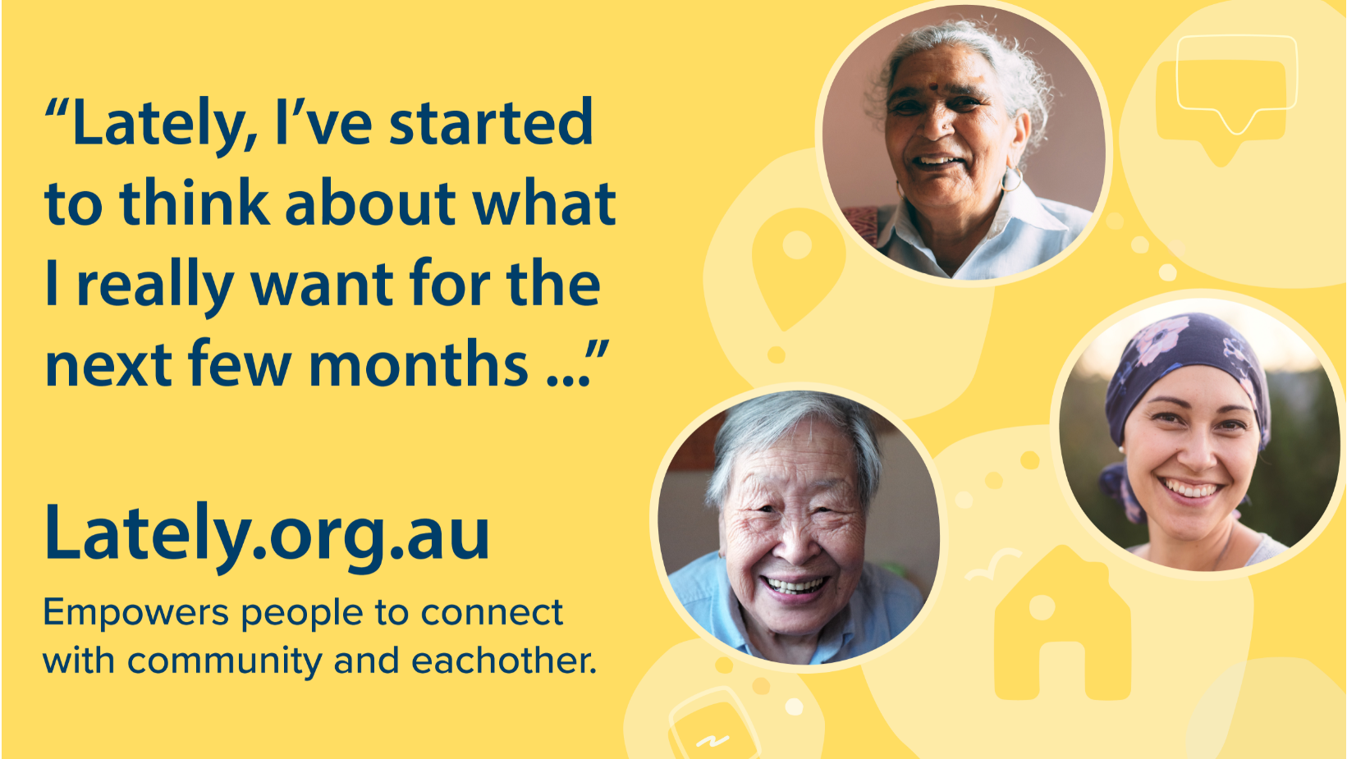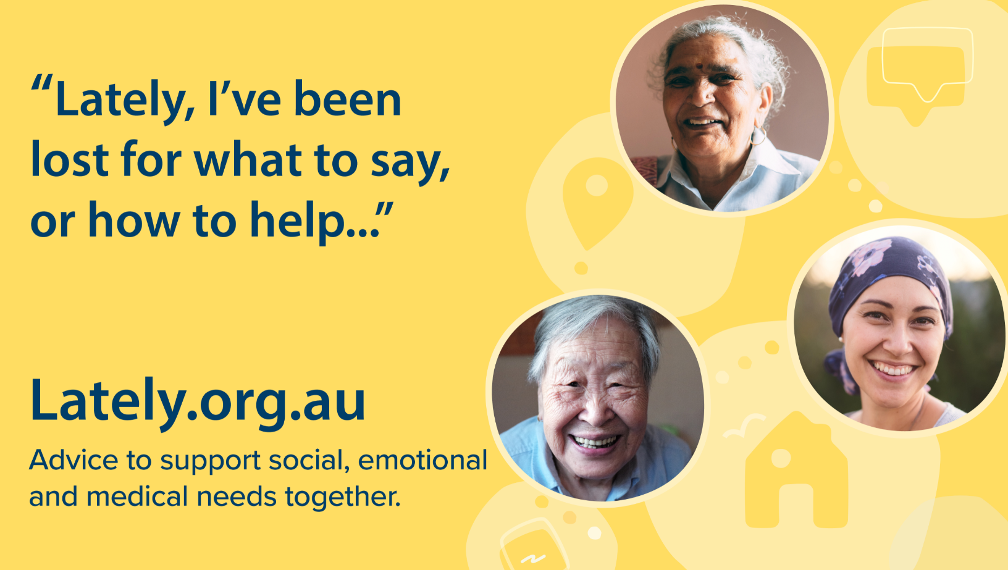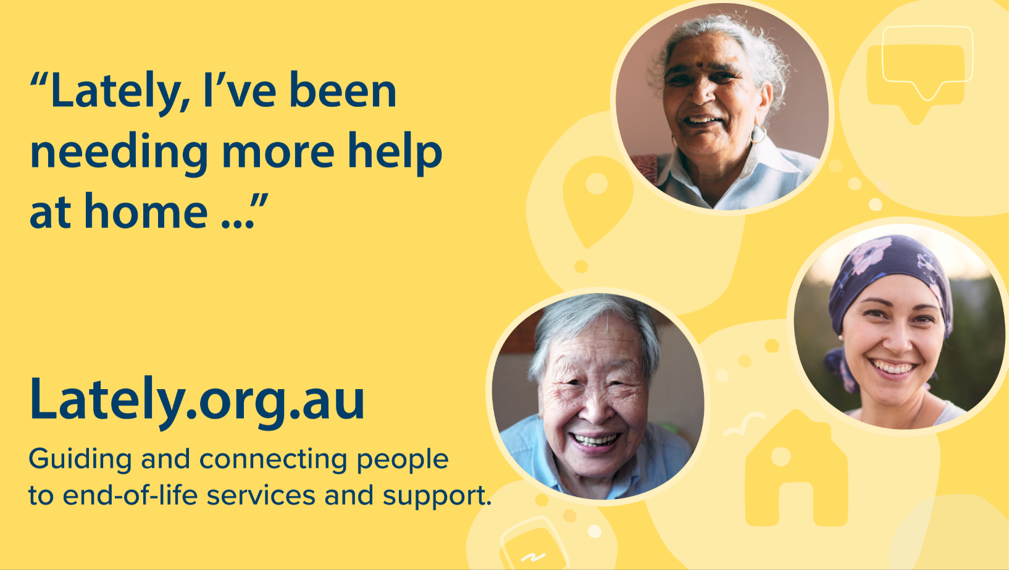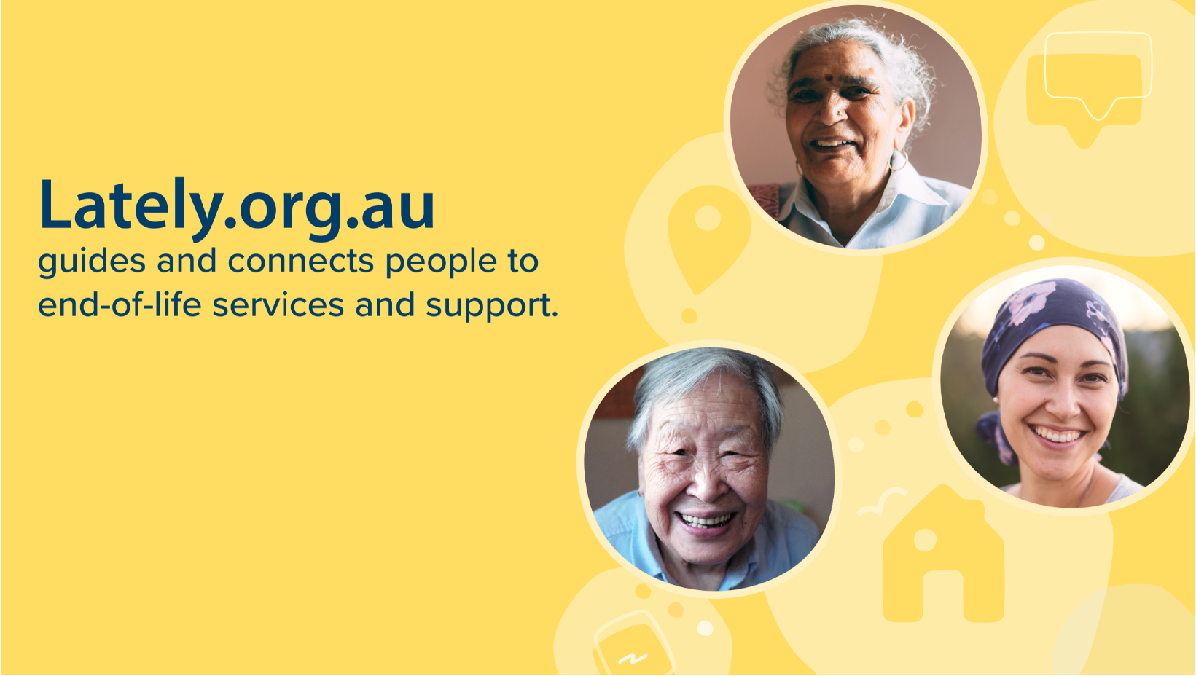

Suggested social media posts

Use the [social media images (.zip)](https://nwmphn.org.au/wp-content/uploads/2021/12/NWMPHN-Lately-Social-1200x6803-1.zip) available on [our website](https://nwmphn.org.au/our-work/priority-populations/lately-end-of-life-services-and-advice-promotion-toolkit/) along with the following suggested posts.

Tags

[@nwmphn](https://www.facebook.com/nwmphn) on Facebook

[@nwmphn](https://www.instagram.com/nwmphn/) on Instagram

[@NWMelbPHN](https://twitter.com/NWMelbPHN) on Twitter

[@nwmphn](https://www.linkedin.com/company/nwmphn) on LinkedIn

Hashtags

#EndOfLifeCare

#DyingWell

#NavigatingHealth

#Lately

Posts

**Facebook/LinkedIn/Instagram – post 1**

Too often discussions about end-of-life planning do not start until it is too late and emotions are running high.

@nwmphn has developed a new service directory to ease communication and planning for people who have received a terminal diagnosis, and for those who love and care for them.

To find out more visit <https://lately.org.au/>

**Facebook/LinkedIn/Instagram – post 2**

Most people are uncomfortable talking about death, and sometimes delay necessary conversations until it is too late.

Lately, a new website developed by @nwmphn, is designed to help people navigate the end of their life.

To find out more visit <https://lately.org.au/>

**Facebook/LinkedIn/Instagram – post 3**

What does it mean to die well? How would you like to spend your end of life period?

Lately, a new website for people in Melbourne’s centre, north and west, is helping people with a terminal diagnosis and their family, friends and carers.

Thanks to @nwmphn for this new resource. Find out more: <https://lately.org.au/>

**Facebook/LinkedIn/Instagram – post 4**

Conversations about the end of a loved one’s life can be tough, but they need to happen early.

Lately provides the resources and concepts to make having those conversations easier.

Find out more: <https://lately.org.au/>

@nwmphn

**Facebook/LinkedIn/Instagram – post 5**

If you or someone you care about is nearing the end of life, local services and support are available.

To explore what dying well can look like, visit <https://lately.org.au/>

@nwmphn

**Facebook/LinkedIn/Instagram – post 6**

What local services and support are available for people at the end of their life, and their supporters?

@nwmphn has built Lately, a new website, to answer this question.

Find out more: <https://lately.org.au/>

**Twitter – post 1**

What does dying well look like for people in Melbourne?

Lately, a new online portal from @NWMelbPHN is helping to answer this question.

Find out more: <https://lately.org.au/>

**Twitter – post 2**

If you or someone you care about is nearing the end of life, local services and support are available.

To explore what dying well can look like, visit <https://lately.org.au/>

@NWMelbPHN

**Twitter – post 3**

Conversations about the end of a loved one’s life can be tough, but they need to happen early.

Lately provides the resources and concepts to make having those conversations easier.

Find out more: <https://lately.org.au/>

@nwmphn

**Twitter – post 4**

Do you provide services or support for people at the end of their life in Melbourne’s centre, north or west?

@NWMelbPHN has built Lately – a new end of life services directory for you and your clients.

Find out more: <https://lately.org.au/>

**Twitter – post 5**

What would you do if you received a terminal diagnosis?

@NWMelbPHN has developed Lately, a new website and local services directory, to help answer this question.

Find out more: <https://lately.org.au/>

**Twitter – post 5**

Too often discussions about end-of-life planning do not start until it is too late and emotions are running high.

@NWMelbPHN has launched Lately to help people have better end of life discussions.

Find out more: <https://lately.org.au/>

About NWMPHN

*North Western Melbourne Primary Health Network (NWMPHN) is one of 31 Primary Health networks in Australia, established to increase the efficiency and effectiveness of medical services, reduce fragmentation of care and improve health outcomes for everyone, especially for the most vulnerable.*

We acknowledge the peoples of the Kulin nation as the Traditional Owners of the land on which our work in the community takes place. We pay our respects to their Elders past and present.

