***Expression of Interest***

Alcohol and other drugs subject matter expert: Expression of Interest

Vacancies exist for a general practitioner and pharmacist (one each) to support recommissioning activities in our alcohol and other drugs (AOD) program.

|  |
| --- |
| North Western Melbourne Primary Health Network (NWMPHN) is looking for a GP and a pharmacist to join a subject matter expert reference group to help guide the recommissioning process of our AOD program.   * We are looking for people who are outcomes-focused and passionate about finding solutions to complex issues. * Expressions of Interest are open to people currently working in general practice or pharmacy, within or outside of the NWMPHN catchment. * This is a short-term opportunity requiring attendance at a maximum of four 2-hour workshops in March and April 2021. * Members will be remunerated for their attendance at workshops. |

Background

Our AOD program is focused on commissioning treatment services that meet the needs of vulnerable communities across our region. In 2019-20 there was approximately $6 million worth of activity funded through this portfolio into the delivery of 28 treatment programs.

In 2021, NWMPHN will recommission[1] approximately $3 million worth of annual activity to address key issues and service gaps that have been identified within the current funding model. Broadly, the recommissioning strategy aims to:

* develop integrated AOD models of care that respond to the diverse and intersecting needs of the region
* strengthen partnerships across sectors and services to bridge gaps between primary and specialist care
* enable the collection of outcome and experience measures to ensure the value of commissioned activity can be measured, and that services are delivered equitably and safely to vulnerable populations
* improve the capacity of general practice and hospitals to respond to AOD, and the capacity of the AOD sector to work with general practice and hospitals.

**NWMPHN will establish two stakeholder groups to guide the recommissioning process:**

|  |  |
| --- | --- |
| Consumer Advisory Group (CAG) | Subject Matter Expert (SME) group |
| The CAG will test and refine problems identified through [The Blueprint](https://www.blueprintforhealth.org.au/home-1) to determine the key barriers effecting access to safe, effective and equitable AOD treatment and support.  This group will provide input on their experiences of the AOD service sector.  The CAG will include people whose lives have been affected by AOD use, who also represent the diversity and complexity of our region. Efforts will be made to include a variety of perspectives and experiences from people including clients, family (or chosen family) members and carers. | The SME group will provide clinical governance and expert input into the development of new AOD models of care by defining the key elements required within the model that improve consumer outcomes and experiences.  This group will support the work of the CAG by ensuring the funding of AOD treatment services meets community needs and is grounded in evidence and best-practice. |

**About the Subject Matter Expert group**

The SME group will include experts who work across a broad range of sectors that intersect with AOD. We aim to include people with expertise in mental health, family violence, ethnocultural identity, housing, general practice, pharmacy, hospital, justice and Aboriginal and Torres Strait Islander health.

We are looking for people who:

* are outcomes-focused and willing to collaborate with others to develop solutions that enhance the wellbeing and safety of vulnerable communities
* are passionate about finding solutions to complex issues, including the abilities to think creatively when problem-solving and to drive innovation and change
* embrace the principles of safe, coordinated, accessible and person-centred care
* are currently working in a general practice or pharmacy.

We are looking for a diverse range of experience. People who are new to practice and emerging leaders as well as those who have experience working within or outside of the NWMPHN catchment are encouraged to apply. You do not need any previous experience in clinical leadership or advisory groups or with NWMPHN to participate.

**Your role as a member of this group**

Members of the SME group will be expected to:

* provide guidance and subject matter expertise that contribute towards improving the health and wellbeing of the community in the NWMPHN catchment
* collaborate with all members of the group by supporting cross-sectoral approaches to problem-solving, innovation and change
* contribute their professional opinion and advice based on experience in general practice or pharmacy
* complete any prior pre-reading before attending meetings and provide feedback on documents outside of meetings, when requested, within the specified timeframe.

**SME meetings**

This is a short-term opportunity focused on the recommissioning of AOD treatment services in 2021. Members will be required to attend a maximum of four 2-hour workshops between March and April 2021. Please note meeting dates and times are yet to be confirmed.

Workshops will be held at the NWMPHN office in Parkville. However, members must have access to IT equipment in the event that meetings take place remotely due to COVID-19, or if they reside in an area where it is not feasible to attend in person.

**Remuneration**

All members will be remunerated for their attendance in accordance with the NWMPHN Stakeholder Reimbursement Policy. There may also be online reading, work and communication required between workshops. A [copy of our reimbursement policy](https://nwmphn.org.au/wp-content/uploads/2021/02/F022-Stakeholder-Reimbursement-Policy.pdf) is provided for reference.

How to apply

If you are interested in this opportunity, please complete the attached application form below.

**Applications close at 5:00pm on Friday, 26 February 2020**.

**Please direct queries and submit completed application forms to:**

Monique Parker

Program Officer, Alcohol and Other Drugs

North Western Melbourne Primary Health Network

**P:** 03 9347 1188

**E:** [monique.parker@nwmphn.org.au](mailto:monique.parker@nwmphn.org.au)

EXPRESSION OF INTEREST: Application Form

|  |  |  |  |  |
| --- | --- | --- | --- | --- |
| **Name:** |  | | | |
| **Contact details:** | **Phone:** | | **Email:** | |
| **Please identify your role:** | **General practitioner** | | **Pharmacist** | |
| **Name of practice:** |  | | | |
| **Practice address:** |  | | | |
| **Does your practice currently receive funding from NWMPHN?** | **Yes** | **No** | | **Unsure** |
| **If yes, please specify:** | | | |
| **Please indicate your preference for meeting times:** | **During business hours** | | **Weekdays after 5:00pm** | |
| **Expression of Interest questions** | | | | |
| **Please provide a brief overview of your experience/area of expertise (max 200 words)** | | | | |
|  | | | | |
| **Why do you want to be a member of the SME? (max 200 words)** | | | | |
|  | | | | |
| **If you could improve one thing about the AOD treatment system, what would it be and why? (max 200 words)** | | | | |
|  | | | | |
| **Please list any current board, professional networking, stakeholder or advisory committees or other like appointments. (Please use bullet points for your response, max. 100 words)** | | | | |
|  | | | | |
| **Additional comments** | | | | |
|  | | | | |
| **Please include details of two referees.**  **Referee 1**  Name:  Role:  Relationship to referee:  Contact details:  **Referee 2**  Name:  Role:  Relationship to referee:  Contact details: | | | | |

Declaration

I declare that I am willing to meet all commitments required for membership of the Subject Matter Expert Advisory Group.

Signed: ___________________________________________________________________________________

Name: ____________________________________________________________________________________

Date: _______________________________________

We acknowledge the peoples of the Kulin nation as the Traditional Owners of the land on which our work in the community takes place. We pay our respects to their Elders past and present.

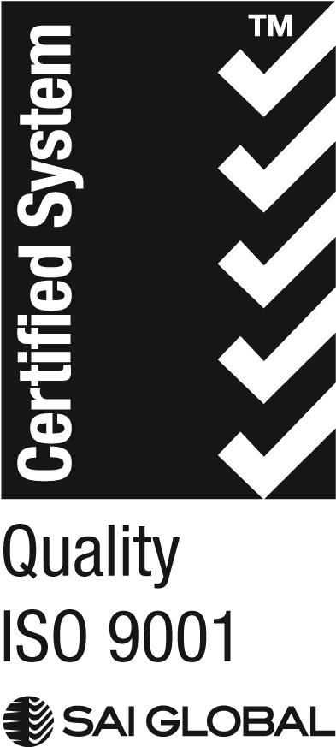

We acknowledge the peoples of the Kulin nation as the Traditional Owners of the land on which our work in the community takes place. We pay our respects to their Elders past and present.



1. Recommissioning is often triggered by changes in community needs, demands or service system structures and involves funding services that are able to effectively respond to these changes.