***Expression of Interest***

Eliminate hepatitis C in general practice: An Intensive Quality Improvement activity

Would your practice like to join the global fight to eliminate hepatitis C by 2030?

Are you looking for a Quality Improvement activity to help you meet the requirements for the new Practice Incentives Program Quality Improvement (PIP QI) Incentive?

We are seeking Expressions of Interest from general practices in the North Western Melbourne Primary Health Network (NWMPHN) region. Don’t miss this chance to improve your skills and confidence to identify and treat patients with hepatitis C.

|  |
| --- |
| IN BRIEF  NWMPHN is offering 10 practices an opportunity to participate in a supported, whole of practice, six-month Intensive Quality Improvement (IQI) activity.  The aim of the activity is to increase the capacity and confidence of general practice to screen, treat and manage patients with hepatitis C. |

Background

Hepatitis C has been a significant public health issue in Australia for several decades. **The prevalence of hepatitis C in the NWMPHN catchment is significant**. The World Health Organisation has set a goal to eliminate hepatitis C as a public health problem by 2030.

New direct-acting antiviral (DAA) medications were made available on the Pharmaceutical Benefits Schemein March 2016 to all people living with hepatitis C, regardless of disease stage. The simplicity and tolerability of these new DAA treatments now provides the foundation for treatment scale-up in primary care settings.

However, after nearly two years of treatment availability, the number of people commencing treatment is falling. Primary practice is seen as a critical avenue to identify individuals living with hepatitis C.

What will your practice receive?

* RACGP-accredited CPD activity (previously 40 Category 1 points)
* Facilitated learning workshops with subject matter experts
* NWMPHN project lead to provide in-practice quality improvement support
* Practice support toolkit
* Opportunity to share, network and connect with other practices involved in the project
* Develop relationships with integrated hepatitis C nurses who can provide ongoing guidance and support
* Monthly PEN data reports
* Structured QI activity to contribute to PIP QI requirements

What is involved?

* Attendance at three (3) RACGP-accredited education and networking workshops
* Participation in an orientation visit and monthly visits from the NWMPHN project lead
* Completion of six (6) Plan Do Study Act Cycles (PDSA) cycles
* Completion of summary reports and a final presentation

Quality improvement is an opportunity to change as a result of learning. Activities lead to positive change in practices, particularly when involving a whole practice team approach. The NWMPHN [Quality Improvement Toolkit](https://nwmphn.org.au/health-systems-capacity-building/quality-improvement/)details the approach in more detail.

How to apply

If you are interested in this project, please complete the attached application form and email to [quotations@nwmphn.org.au](mailto:quotations@nwmphn.org.au)

**Applications close at 5:00pm AEDT on Friday, 6 March 2020.**

For more information or to apply:

Gareth Davies  
Director, Procurement  
North Western Melbourne Primary Health Network  
**Phone**: (03) 9347 1188  
**Email**: [quotations@nwmphn.org.au](mailto:quotations@nwmphn.org.au)

|  |
| --- |
| ABOUT PHNs  Funded by the Commonwealth Department of Health, Primary Health Networks (PHNs) began operation on 1 July 2015 and are responsible for coordinating primary health care and facilitating improved health outcomes in their local community. Melbourne Primary Care Network operates the North Western Melbourne Primary Health Network (NWMPHN). |

We acknowledge the peoples of the Kulin nation as the Traditional Owners of the land on which our work in the community takes place. We pay our respects to their Elders past and present.

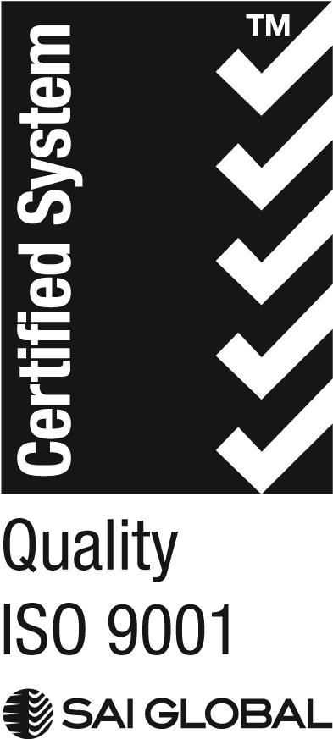

We acknowledge the peoples of the Kulin nation as the Traditional Owners of the land on which our work in the community takes place. We pay our respects to their Elders past and present.



EXPRESSION OF INTEREST: Eligibility form

Eliminate hepatitis C in general practice – Intensive Quality Improvement activity

You must be able to tick each of these boxes to be eligible to nominate. The practice must:

Be located within and provide services to the North Western Melbourne Primary Health Network region.

Be accredited or working towards accreditation.

Be able to complete the program between March 2020 and September 2020

Have a minimum of two practice staff (one of whom must be a GP) as part of the project team. These staff will actively participate in the learning workshops (March, June, September 2020) and quality improvement activities and champion the program in the practice.

Have a clinical and billing system that is compatible with PEN CAT (data aggregation tool), or agree to have PEN CAT installed, and a data sharing agreement in place.

Agree to allocate protected time for the quality improvement team to complete project tasks, to attend program workshops and to receive regular (monthly) visits from the NWMPHN Primary Health Care Improvement team member.

Agree to implement a minimum of six Plan, Do, Study, Act (PDSA) cycles and provide PDSA documentation to NWMPHN within agreed timeframes.

Agree to complete required surveys and reporting.

EXPRESSION OF INTEREST: Application

Eliminate Hepatitis C in General Practice – Intensive Quality Improvement (IQI) activity

|  |  |  |  |  |
| --- | --- | --- | --- | --- |
| **Applicant name:** | | | | |
| **Name of practice:** | | | | |
| **Practice address:** | | | | |
| **Applicant details:** | **Phone:** | | **Email:** | |
| **Practice manager details:** | **Phone:** | | **Email:** | |
| **Practice principal details:** | **Phone:** | | **Email:** | |
| **EXPRESSION OF INTEREST QUESTIONS** | | | | **WEIGHTING** |
| 1. **Please provide a brief overview of why your practice would like to participate in this project. We are seeking demonstration that there is a whole of practice commitment.** | | | | 30% |
| 1. **How will your practice team benefit from participation in this quality improvement project?** | | | | 20% |
| 1. **How will your patients benefit from your practice’s participation in this project?** | | | | 20% |
| 1. **What barriers do you think may limit your participation in and successful completion of this project? How will you seek to overcome them?** | | | | 15% |
| **BARRIERS**  Please list.  For example: Loss of staff involved in the project | | **MITIGATION STRATEGY**  For example: Discussion of project at team meetings. Project documents stored centrally and accessible to all staff. Engagement of multiple team members. | | |
|  | |  | | |
| 1. **How will you plan to make changes sustainable beyond the project?** | | | | 15% |
| **ADDITIONAL QUESTIONS** | | | | **NON-WEIGHTED** |
| **Please list the name and profession of participating staff members:** | | | | - |
| **Please provide any additional information to support your application:** | | | | - |

**Please return the completed application form to** [**quotations@nwmphn.org.au**](mailto:quotations@nwmphn.org.au)

**Applications close at 5:00pm AEDT on Friday, 6 March 2020.**