Chronic pain management in the primary care setting

We are seeking feedback from our community on the outcomes of a recent market sounding process. This activity brought together service providers, clinicians, GPs and pain specialists to map chronic pain pathways and identify possible solutions to identified gaps and barriers.

We invite you to review this summary document from the market sounding session and provide your feedback or comments.

The market sounding session and a range of other activities have informed North Western Melbourne Primary Health Network’s (NWMPHN’s) understanding of chronic pain management and the services within our catchment. Overall these insights will inform the upcoming commissioning activity relating to chronic pain management in the primary care setting, due to be released for tender early in 2020.

Please email your feedback (either in this document, or the email body) to Natalie Seed, Program Officer, Integration: [natalie.seed@nwmphn.org.au](mailto:natalie.seed@nwmphn.org.au), or call on 03 9347 1188, by Wednesday, 27 November 2019.

Insights into future commissioning activities

NWMPHN is developing insight into chronic pain management to inform future commissioning activities. NWMPHN has conducted a number of activities to inform our understanding of chronic pain management across the primary and tertiary care settings.

Work to date includes a review of the literature, a needs assessment, and stakeholder engagement. This work is complimented by the Australian Prevention Partnership Centre’s (APPC) ongoing project, focused on initiatives to improve the prevention and management of chronic pain in primary care.

A market sounding session on the management of chronic pain

Stakeholders at the session were asked to find gaps in the current system and to identify approaches that could address these gaps. The findings underlined a number of issues including:

* a lack of pain services based in the community setting;
* long waiting lists for specialist pain services;
* a need to take a multidisciplinary approach to pain using a biopsychosocial model to understand patients; and
* the positive outcomes of self-management programs.

Mapping a patient journey for a person with chronic pain

Attendees were asked to discuss and map the journey for a consumer with chronic pain. The diagram (over page) was used as a guide, helping participants to identify key issues across the three areas of the patient journey: ‘finding out’, ‘attempting & adapting’ and ‘normalisation’.

Gaps and barriers identified across the first ‘finding out’ and ‘attempting & adapting’ are listed, as are the identified enablers for achieving effective management of people living with chronic pain.

**THE PATIENT JOURNEY**

*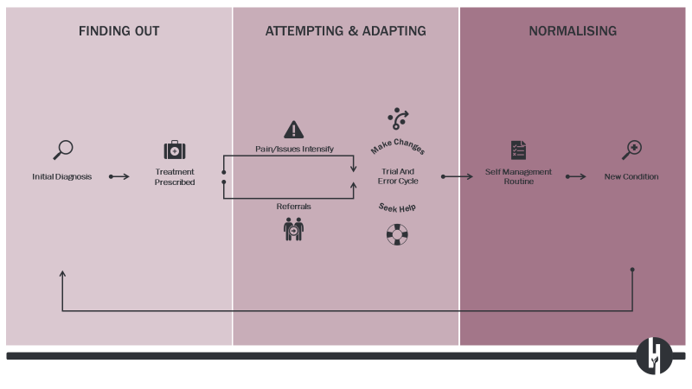Source: Commissioned Report “The WHOLE You”, Harvest Insights (2018)*

1. *Barriers and gaps – Phase 1*

|  |  |
| --- | --- |
| ***THEME:*** | ***PHASE 1: FINDING OUT*** |
| **Consumer Health Literacy and knowledge** | **Barrier:** Patients often have unrealistic expectations of pain/pain management; patients want immediate results, but this isn’t the reality -> pain is poorly understood |
|  | **Gaps:** Access to consumer education to build knowledge and awareness of pain; poor knowledge can lead to a discord between patient expectations and the reality of managing chronic pain; availability of culturally appropriate services |
| ***Theme:* Clinician Confidence/Experience** | **Barrier:**  Low clinician confidence that good outcomes can be achieved |
|  | **Gaps:** Poor understanding of pain and the management of pain among some professionals |
| ***Theme: S*ervice capacity and capability** | **Barrier:** Consultation time is limited; clinicians are busy and can feel they have exhausted their options |
|  | **Gaps:** Early treatment options; planned care is often lacking from the outset – clear guidance or models of care required |
| ***Theme:* Consumer experience** | **Barrier:** Stigma – both in mannerisms and expectations linked to language used (e.g. ‘painkillers’) affects whether a patient seeks treatment, and the treatment they receive when they do. Often this leads to a delay in diagnosis; Transport; Cost of services |
|  | **Gaps:** Support for family members to assist a loved one with pain. Little available information for families and carers, and there is poor knowledge about options to get help |

|  |
| --- |
| *Do you have any comments about the listed barriers and gaps, and are there any you wish to add?* |

1. *Barriers and gaps – Phase 2*

|  |  |
| --- | --- |
| ***Theme:*** | ***Phase2: attempting & adapting*** |
| ***Theme:* Consumer experience** | **Barrier**: Range of access issues including cost and transport; Patient engagement – addressing pain needs can be “too hard” |
|  | **Gaps:** Support for family members to assist a loved one with pain. Little available information for families and carers, and there is poor knowledge about options to get help |
| ***Theme: S*ervice integration** | **Barrier:** Barrier: Difficult communication between GPs, patients, specialists and allied health providers |
|  | **Gaps:** No linkage between public and private services; appropriate and actionable discharge communication |
| ***Theme: S*ervice access** | **Barrier:** Long waitlist for publicly funded clinics – private services are available but not all patients can afford/are covered; perception of long waitlists, though not always the case – often triaged by need and access can be variable across offerings. |
|  | **Gaps:** Service options in a community setting for patients on specialist waiting lists – especially for priority populations groups; transition/early access clinics (for subacute pain) that offer a preventative approach; need for pain rehab programs and community navigators; need available allied health practitioners, especially those with an interest in and capacity to address pain |
| ***Theme:* Health system** | **Barrier:** Care that is long term – treatment may lead patients to feel better in the short term but chronic pain requires consistent rather than brief treatment ; State funded chronic pain clinics under HIP/SACS model which doesn’t appreciate comorbidities; Medicare funds GP’s with item numbers to consult time not complexity; limited allied health; community health is block funded largely by the state. |
|  | **Gaps:** Funding – system doesn’t support access to evidence-based treatment modalities based on specific cause of pain and individual’s characteristics |
| *Do you have any comments about the listed barriers and gaps, and are there any you wish to add?* | |

1. *What are the enablers to better care?*

A number of enablers were identified to address/overcome the gaps and barriers and to meet the needs of patients with chronic pain in primary care.

* Time
* Patient education
* GP education
* Nurse practitioners
* Utilisation of SafeScript and My Health Record
* Skills of specialist pain clinicians (doctors, nurses, allied health)
* Hope – patients need reassurance at the start of their journey. Many give up.
* Motivation – some will be prepared and enabled/empowered to self-manage, but many will not. They need specific support.
* Support to access services e.g. health navigators / patient advocacy
* Having a plan – GPs able to set goals with patient and monitor these.

*Are there any other enablers that you wish to identify?*

**A FUTURE SERVICE MODEL**

1. *Developing a future service model*

Having discussed the typical pathway for patients, as well as the array of associated issues and gaps, some initial ideas emerged around potential future services.

Early Access Clinic / Early intervention in pain:

* Develop an effective (multidisciplinary) screening tool to be able to identify all risk factors affecting the individual, and be able to suitably triage patients
* Support those with the capacity and motivation to self-manage their condition
* For those who are unable to self-manage, early referral is needed
* A ‘no wrong door’ approach to referrals.
* Either hospital or community based
* Could be condition specific such as post-operative or back

Transition Clinic - whilst on waiting list

* Rapid access pathway including education
* E-health options
* The pathway could use a clinical (multidisciplinary) panel to make a combined assessment of the patient before suitable referrals.

*Are there any other ideas to inform a future service model?*

1. *Principles for design of future chronic pain services:*

* Responsive – services should meet people where they are
* Proactive care – early intervention is required
* Connected care – communication between services and providers
* Education – for consumers and clinicians
* Appropriate Pathways – consumers should be triaged to appropriate care and clear and actionable steps should be provided to primary care clinicians to support treatment and management

*Do you have any comments on the set of principles above?*

1. *Key recurring themes:*

* Expectations – chronic pain requires management and establishing appropriate expectations with patients is key
* Communication and understanding of the patient at their first contact with the health system is vital
* Education and training should draw on existing knowledge and support them to implement care and support patients to navigate the system
* Stigma is a significant issue
* Communication between services is poor. As a result, patients bounce back and forth between GP and range of allied services, to little avail.
* Active intervention and support are required as early as possible – ideally before chronic pain has developed
* Some patients will be able to self-manage, but many won’t. A clear and effective screening/triage process is required to determine which pathway is most suitable for each cohort.

*Do you have any comments on the themes above?*

1. *Your ideas help us provide better care.*

Please add any other comments here

*Thank you for taking the time to respond to this important piece of work. Your feedback will be combined to help inform our next commissioning in chronic pain management.*

We acknowledge the peoples of the Kulin nation as the Traditional Owners of the land on which our work in the community takes place. We pay our respects to their Elders past and present.

