Long Term Goal | Repeated use of the PDSA Cycle  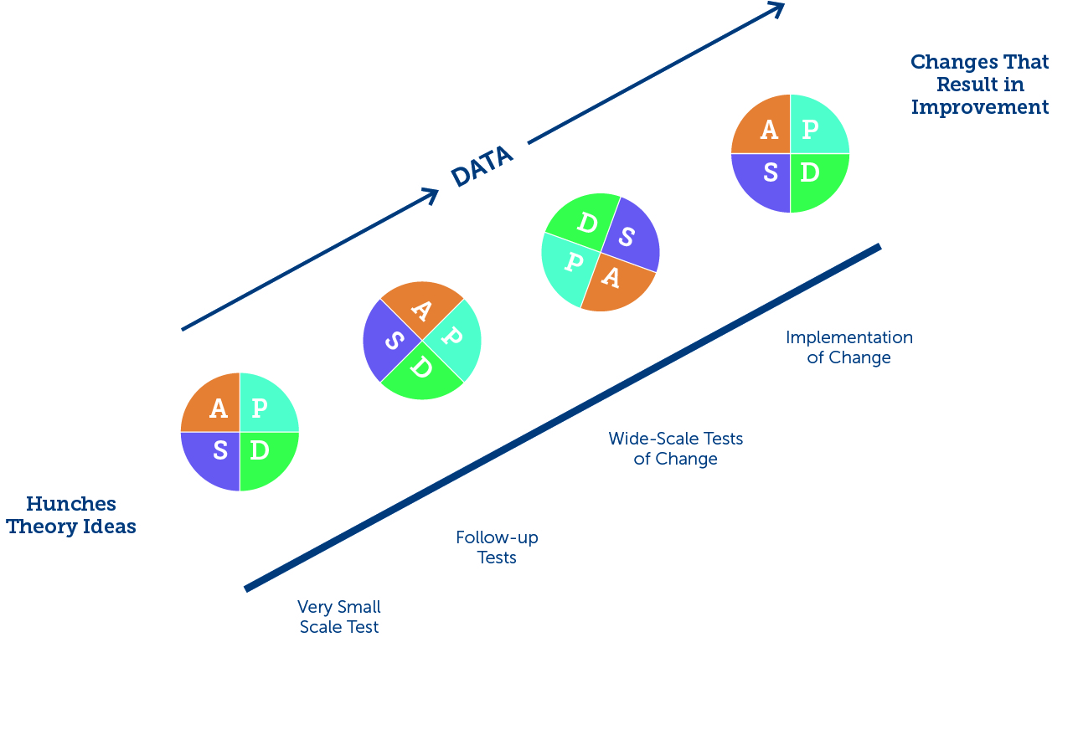 | Anticipated Result
 |  | Cycle 5:
 |  | Cycle 4:
Short Term Goal |  | Cycle 3:
 |  | Cycle 2:
 |  | Cycle 1:
Goal to Action Planning

